13th February 2018

VALLIS TRADE ASSURANCE SERVICES (VTAS)

stock AUDIT and inspections in hargeisa and berbera, SOMALILAND
Vallis Trade Assurance Services (VTAS) was nominated as Independent Surveyors to audit and inspect stock stored in Hargeisa and Berbera, Somaliland.

As part of the inspection, VTAS conducted a stock count, inspected the storage facility and cargo as well as performed sampling and analysis.

Below is a series of photographs that depict the services VTAS provided as part of this contract.

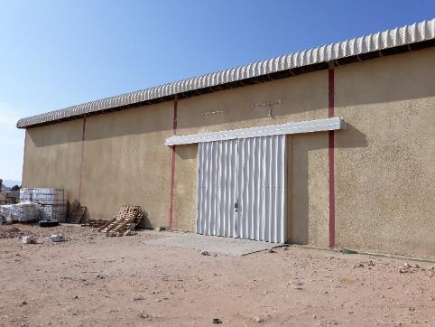 | 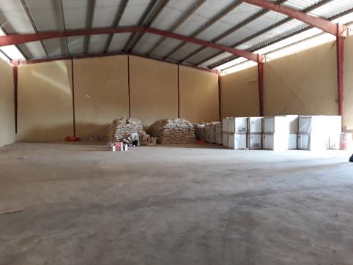
1. Warehouse in Berbera to be inspected. | 2. Cargo stored inside warehouse.
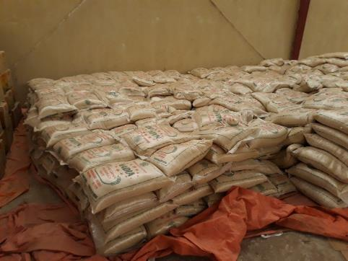 | 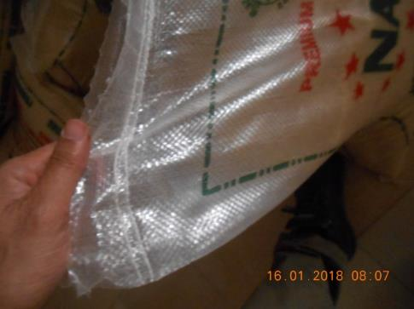
3. Cargo stored in warehouse to be counted and inspected. | 4. Inspection of quality of stitching.
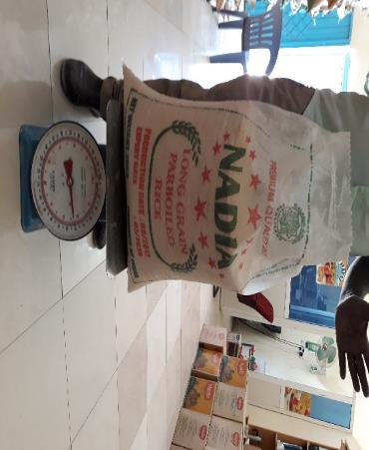 | 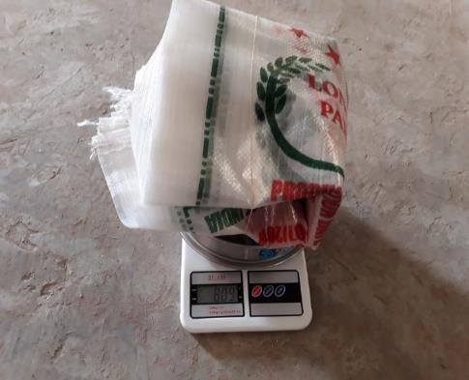
5. Random weighing of bags. | 6. Weighing of empty bags.
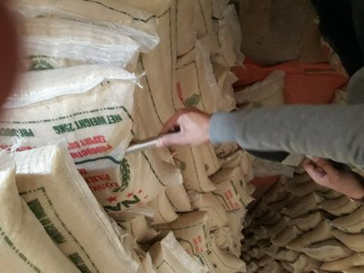 | 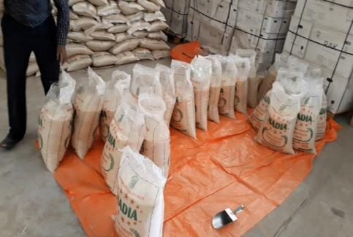
7. Sampling of goods using sample spear. | 8. Random sampling from bags.
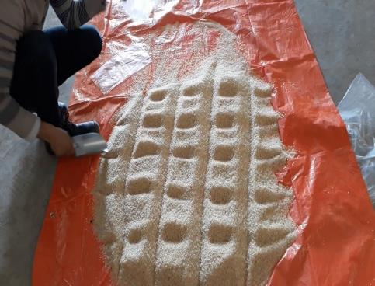 | 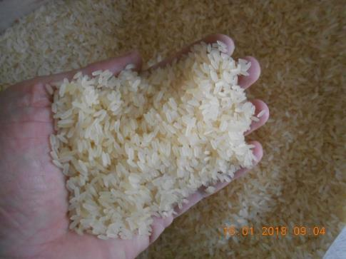
9. Mixing and dividing samples to get a representative sample. | 10. Inspection of grains.
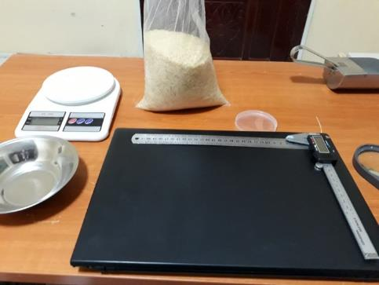 | 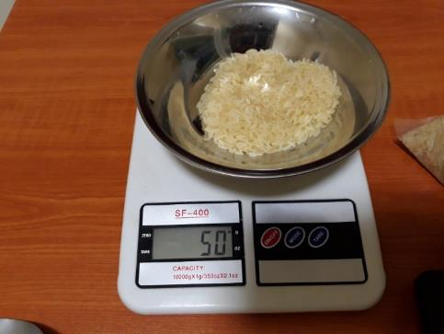
11. Tools used to analyse percentage broken of samples. | 12. Representative sample to be inspected.
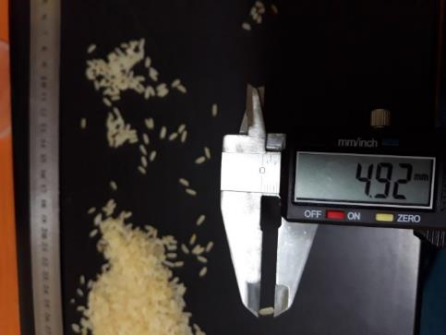 | 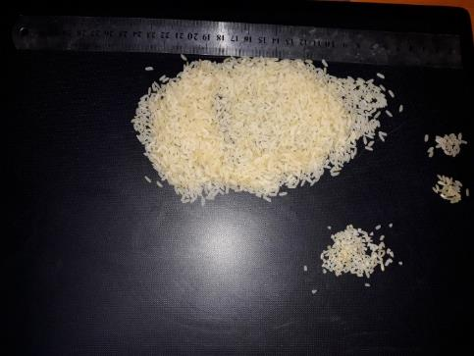
13. Checking average length of the grains. | 14. Visual inspection of the damaged, red, yellow and broken kernels.
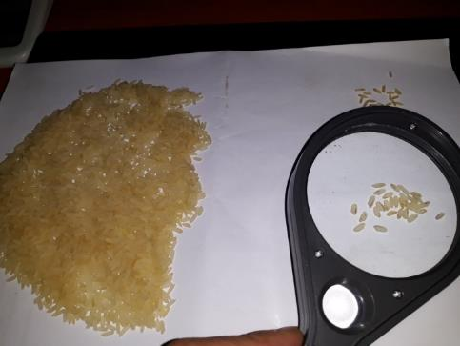 | 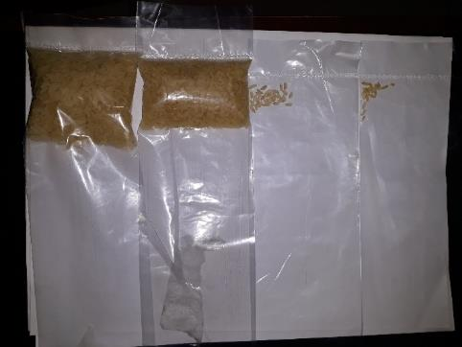
15. Visual inspection of the damaged, red, yellow and broken kernels. | 16. Sorting of damaged, red, yellow and broken kernels to be weighed.

Pictures List:

1. Berbera warehouse to be inspected. 1
2. Cargo stored inside warehouse. 1
3. Cargo stored in warehouse to be counted and inspected. 1
4. Inspection of quality of stitching. 1
5. Random weighing of bags. 2
6. Weighing of empty bags. 2
7. Sampling of goods using spear. 2
8. Random sampling from bags. 2
9. Mixing and dividing samples to get a representative sample. 2
10. Inspection of grains. 2
11. Tools used to analyse percentage broken of samples. 3
12. Representative sample to be inspected. 3
13. Checking average length of the grains. 3
14. Visual inspection of the damaged, red, yellow and broken kernels. 3
15. Visual inspection of the damaged, red, yellow and broken kernels. 3
16. Sorting of damaged, red, yellow and broken kernels to be weighed. 3

