TUNISIA
27th February 2019

TUNISIA’S ACCESSIBLE MEDITERRANEAN SEA COASTLINE AND STRATEGIC LOCATION HAVE ATTRACTED CONQUERORS AND VISITORS THROUGHOUT THE AGES, AND ITS READY ACCESS TO THE SAHARA HAS BROUGHT ITS PEOPLE INTO CONTACT WITH THE INHABITANTS OF THE AFRICAN INTERIOR.

Official Named: The Republic of Tunisia

Location: North African country bordering the Mediterranean Sea and the Sahara Desert.
- Bordered by Algeria and Libya.
- Tunisia contains the northernmost point of the African continent (Cape Angela).
- Tunisia contains the eastern end of the Atlas Mountains.

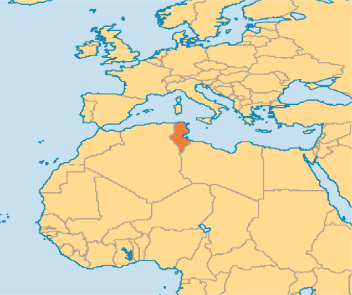

- It is in the Maghreb region of North Africa, covering 163,610 km².
- It is the smallest country in north western Africa.
- 1300km of coastline include the African conjunction of the western and eastern parts of the Mediterranean Basin.

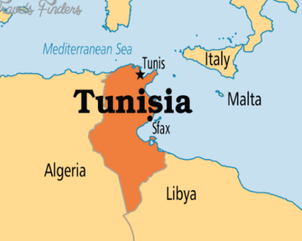

Languages:
- Arabic is the official language, and Tunisian Arabic, known as Tounsi, is the local dialect, which is used by the public.
- French plays a major role in Tunisian society, despite having no official status. It is used in education (children are taught from the age of 8), the press and in commerce. In 2010, there were 6,639,000 French-speakers in Tunisia (64% of the population). French is also used on signs and menus.
- English (Tamazight) is now a compulsory subject, taught form the age of 10. English may soon become Tunisia’s third official language.

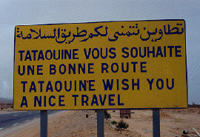
Total Population: 11,595,000 people (2018 est.)
Distribution: Urban 68.9% - Rural 31.1% (2018)
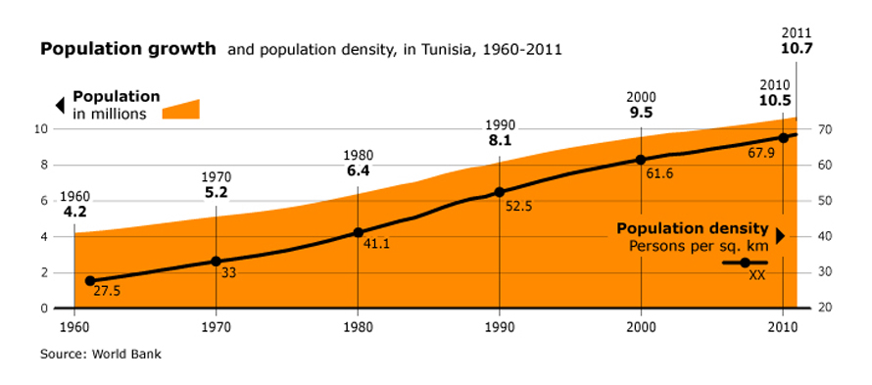

Population projection: 12,871,000 (2030)

Capital City: Tunis
- Tunisia’s name is derived from its capital city Tunis, which is located on its northeast coast.
- It is Tunisia’s largest city.
- Home to the headquarters of 2/3rds of Tunisia’s finical services companies, creating the capital as an essential business hub.
- Tunisia doesn’t have a city with more than 1 million people.
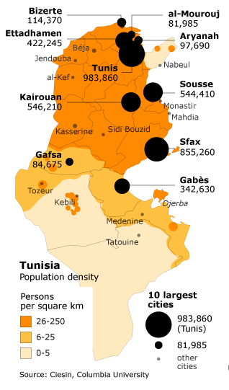

Ethnic Groups: The majority of North Africa’s population west of Egypt is Berber in Ethnic origin. Nowadays Berbers proudly call themselves amazigh (m), tamazight (f) or imazighen (plural), meaning ‘free men’ or ‘noble people’.
- Arab – Berber 98%
- European 1%
- Jewish & Other 1%

Religion: Islam is the state religion. Tunisia is predominantly Sunni Muslim.
- Sunni Muslim 99.1%
- Other 1% (includes Christian, Jewish, Shia Muslim and Baha’i)

Currency: Tunisian Dinar
- Exchange rate as of 2019: 1 USD = 3.06 TDN
- Confusingly 1 dinar is equivalent to 1000 millimes (not the normal 100).
- It is not an internationally traded currency and therefore is not available outside the country.

Visas: Most nationalities do not need a tourist visa to enter the country, apart from Australia and South Africa – However these are relatively easy to obtain upon entry.

Literacy: 86.1% males and 72.2% off males aged 15 and over are literate.

CLIMATE
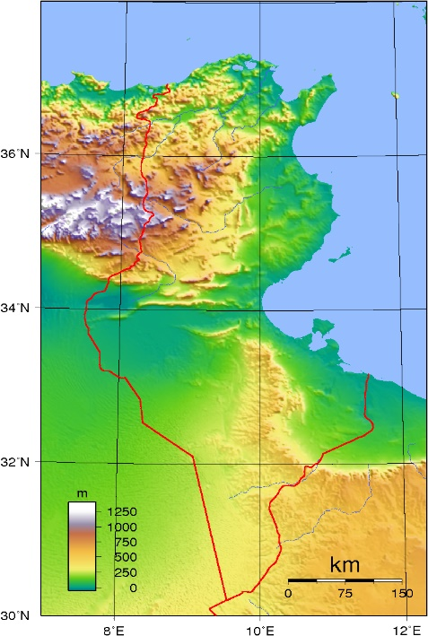
Though relatively small, Tunisia has great environmental diversity due to its north-south extent.
Atlas
Mountains
Sahara
Desert
Coastal area, popular with holiday makers

Tunisia is situated in the warm temperate zone between latitudes 37° and 30° N.

The Northern Coast:
- Mediterranean climate, with no marked intervening seasons.
- Mild, rainy winters (highs of 16/18 °C)
- Hot, dry summers (highs of 32/33 °C)
- The coastal and mountainous regions of Tunisia can be affected by the desert wind, which causes an increase in temperature by several degrees, but also a drop in relative humidity, and may also bring sandstorms.
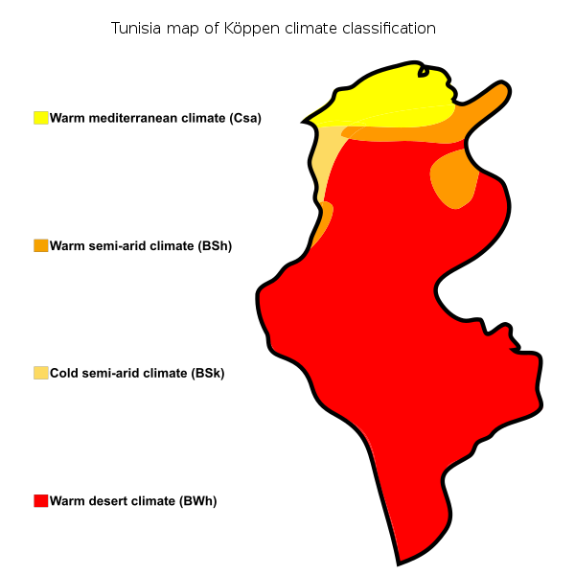
- During these periods it can be hot, especially from June to September, when the temperature can exceed 40 °C (104 °F) in Tunis and along the east coast.
Warm
Semi-Arid
Climate
Cold Semi-Arid
Climate
Warm Desert
Climate
Warm
Mediterranean
Climate

The Central & Southern Inland:
- Temperature range is significantly more extreme. Desert climate
- In the winter, night-time temperatures can drop below 0 °C.
- In the summer, temperatures reach 50 °C.
- Rainfall sharply decreases southward from any point, with periodic droughts.

Visiting:
- The capital Tunis is in the North, on the coast, along with many other beach areas that a predominately visited to by tourists. They receive a yearly climate similarly to the Mediterranean, with sunshine and minimal rainfall in the summer.
- Saharan influences give rise to the sirocco, a seasonal hot, blasting wind from the south that can have a serious drying effect on vegetation.

Natural Recourses:
- Lead
- Iron Ore
- Phosphates
- Petroleum
- Zinc

National holidays: Tunisians observe the standard Islamic holidays as well as several secular and national holidays, such as Independence Day (20th March) and Women’s Day (13th August).

Vaccines: No vaccinations are required by law
- Typhoid and Hepatitis A are strongly recommended.
- Tunisia is malaria free.
.

Figure 1 & 2: Tunisia experiences Mediterranean climates in the north desert climates in the south.

DEMOGRAPHICS
Tunisia’s estimated population is 11,595,000 people. Tunisia is not densely populated, with just 63 people per square kilometre (163/sq mi), which ranks 133rd in the world. However, the population of Tunisia doubled during the last three decades of the 20th century. Even though the country’s natural growth rate, is less rapid than other North African countries, the population growth has been reduced to just over 1% per annum, contributing successfully to Tunisia’s economic & social stability.

Accomplished by:
- Family planning to lower birth rate – Tunisia has one of the lowest birth rates on the African continent.
- By raising the social, economic, and legal status of women.
- Emigration – depresses overall growth rate, with many Tunisian’s being employed abroad, notably France and the Middle East.

Tunisia’s favourable demographic situation is reflected in its:
- High life expectancy
- Male (2017) = 74.1 years
- Females (2017) = 77.4 years
- High living standards
- The country’s national health system provides nearly all its population with access to medical care.
- A good network of hospitals and clinics has contributed to a relatively low death rate.
- Declining infant mortality rate
- 22.5 deaths/1,000 live births (2010 est.)
- Tunisia has one of the lowest infant mortality rates on the African continent.
- Education
- Education is free to all school age children, being compulsory between the ages of 6 and 16.
- Marriage occurring at older age
- Progressive aging of the population.

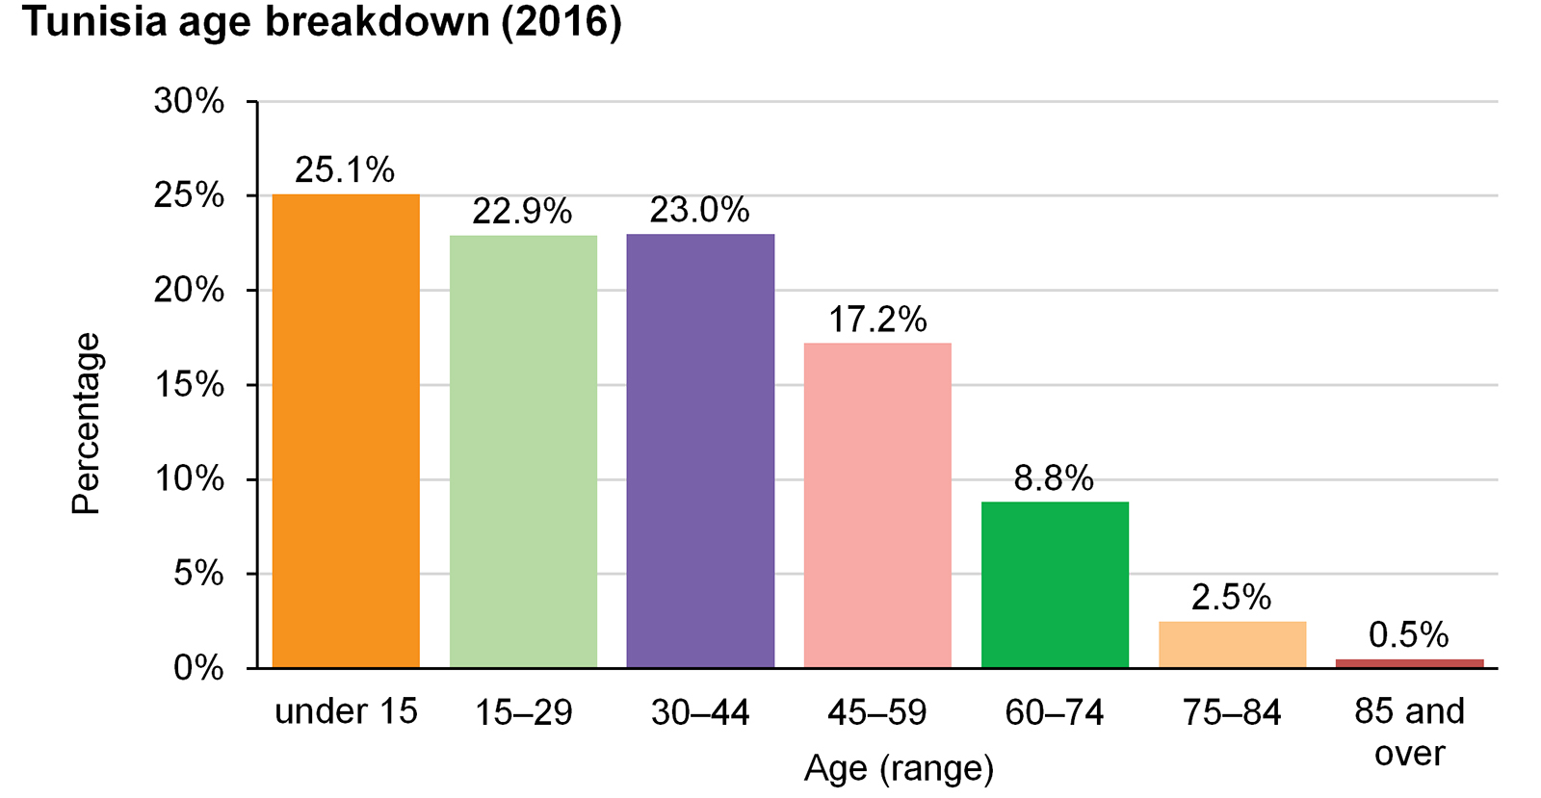
Figure 3: Just below half the population are aged between 15 and 44 years old

However, growth in the number of schools, students and teachers has created a serious financial strain, as education has constituted one of the largest shares of the annual national budget.
MIGRATION
While many modern Tunisians identify themselves as Arabs, they are mainly the descendants of Berbers, and to a lesser extent of Arabs.
- Less than 20% of the genetic material comes from the Middle East.
- In addition, there was people from numerous civilizations that have invaded, migrated to, and been assimilated into the population over the millennia.

After the French colonization of Tunisia in 1881 from the Ottoman Empire, making Tunisia a French protectorate, European settlements in the country were actively encouraged.
- The number of French colonists grew from 34,000 in 1906 to 144,000 in 1945.
- In 1910, 105,000 Italians were in Tunisia.

Virtually all the European and Jewish population left Tunisia after the country gained independence in 1957. There was a history of a Jewish population on the southern island of Djerba going back 2,000 years. While the 1948 Jewish population was over 105,000, it was reduced to just 1,500 by 2003.

Net Migration Rate:
- -0.41 migrant(s)/1000 population (2010 est.)
- -1.8 migrant(s)/1000 population (2017 est.)

Tunisia has also rapidly become an immigration and transit country, with migrants coming mainly from the Maghreb and from Sub-Saharan Africa whose aim is to reach Europe through irregular migration from the Tunisian coasts.
- More than 25,500 Tunisians took to the sea in the aftermath of the fall of the Ben Ali regime (2011) with the hope of finding work or joining their families or friends in Europe.

Furthermore, Tunisia has experienced an upsurge in immigration since the Libyan crisis started in early 2011, after which nearly 350,000 fled Libya via the Tunisian border during a few months (including 97,000 Tunisian returnees).

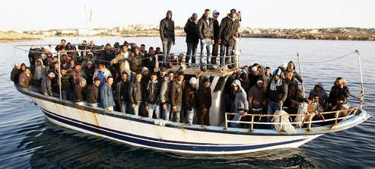

Figure 4: Tunisia is often used as a starting point by migrants, who often make the journey to Europe in overcrowded, makeshift boats.

Tunisia is a country impacted by the migrant crisis, which has seen unprecedented numbers of people trying to reach Europe via the Mediterranean since 2015.
INFRASTRUCTURE
Tunis is at the centre of the transport system as the largest city having the largest port and light transit system.

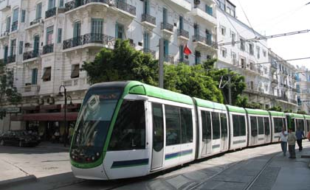
Figure 5: Light transit system in Tunis forms easy public transport in the capital city.

Airports: The main airports out of the 29 airports
in Tunisia, which service its sizable tourist trade are:
- Tunis Carthage International Airport – flies to 60 different destinations
- Enfidha - Hammamet International Airport
- Djerba-Zarzis International Airport

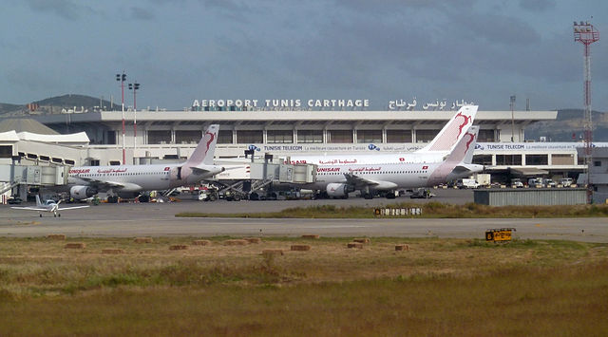
Figure 6: Tunisair is headquartered in Tunis, flying internationally.

Roadways: The network of roads and railways is sufficiently dense so that all cities of any importance are linked with the interior. The country maintains 18,997km of roads
- 12,424km surfaced (including 142km of highways)
- 6,573km unsurfaced

Tunisia is connected by both road and rail to Algeria but only by road to Libya, since the railway ends at Gabès. Work is under way to modernize and extend the railway network, which amounts to 2,135 km in total.

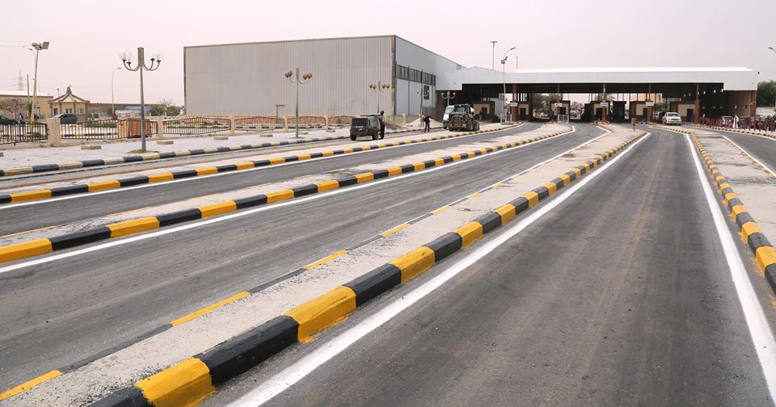
Figure 6: Tunisia border crossing to Libya
Ports: Tunis is the most significant port in Tunisia with other significant ports on the Mediterranean Sea including Bizerte, Gabès, La Goulette, Sfax, Sousse and Zarzis.
Tunisia ports play an important role in the export and import trade in the country. The ports authority of Tunisia runs the seaports, which is operated by the Government of Tunisia. The ports authority of Tunisia provides safe and efficient transportation system that ensures safe trading in the ports and improved the economic prosperity of the country. The port authority of the country is managing, exploiting and maintaining the waterways including Tunisia ports.

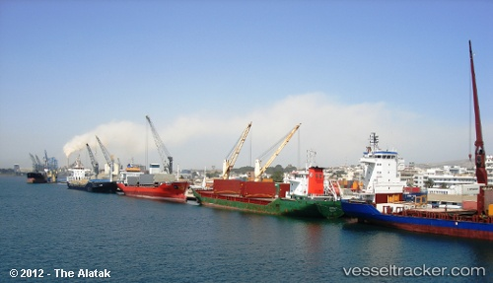
Figure 7: With 1,148km of coastline, export and import trade occurs mainly through the ports
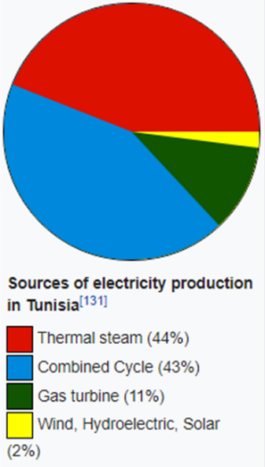
Electricity: Most of the electricity used in Tunisia is produced locally, by state-owned company STEG. In 2008, a total of 13,747 GWh was produced in the country. Tunisia has abandoned plans for 2 nuclear power stations, but is diversify its energy mix, such as renewable energies, shale gas and constructing a submarine power interconnection with Italy.
Figure 8: A pie chart showing the distribution of how electricity is produced.
Water: Tunisia has achieved the highest access rates to water supply and sanitation services in the Middle East and North Africa. As of 2011, access to safe drinking water became close to universal approaching 100% in urban areas and 90% in rural areas. Tunisia provides good quality drinking water throughout the year.

Oil: Oil production began in 1966 in Tunisia. Currently there are 12 oil fields.
- Oil production of Tunisia is about 97,600 barrels per day (15,520 m3/d).
- The main field is El Bourma.
POLITICAL HISTORY
Tunisia is the smallest of the Maghrib states and consequently the most cohesive. By the 19th century, virtually all its inhabitants where Arabic speaking Muslims, with a single major city, Tunis, dominating the countryside both politically and culturally. More easily controlled from within than any other Maghrib country, Tunisia was also more open to the influence of people and ideas from abroad.

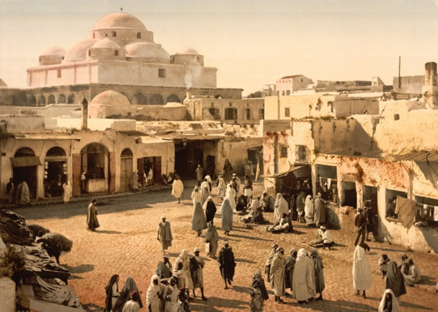
Figure 9: Tunisia during the French colonization

The French granted full independence to Tunisia in an accord that was reached on 20th March 1956, and Habib Bourguiba was chosen prime minister. The rule of the beys was subsequently abolished, and on 25th July 1957, a republic was declared, with Bourguiba as president He ruled until 1987.

Bourguiba’s long rule, widely popular in its early years, had provoked an increasing but passive opposition among Tunisians. Bourguiba, long in declining health, became unable to mask his autocratic tendencies. He appointed General Zine al-Abidine Ben Ali, after being deemed mentally unfit to rule.

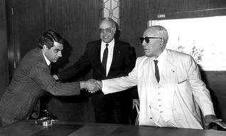
Figure 10: Bourguiba (right) and Ben Ali (left)

Ben Ali promised political liberation and a transition into democracy and won re-election 1994, 1999, 2004 and 2009, each time by an overwhelming margin. Which meant that there was no form of power sharing away from the president and his party. Ben Ali’s powerful presidential regime backed by a single political party became increasingly authoritarian. Specifically, its abuse of human rights and its reliance on brutal military and security forces.

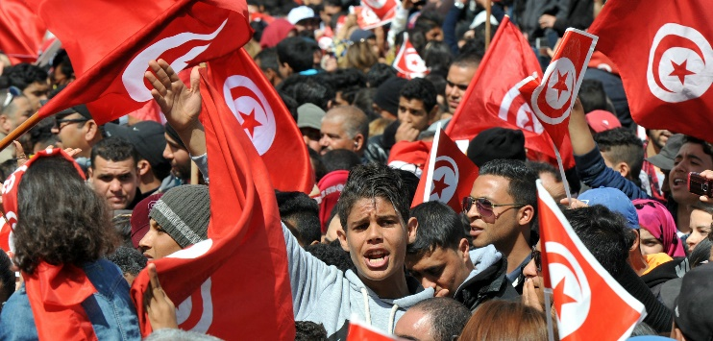
Figure 11: The general public protesting

The Jasmine Revolution → The Arab Spring:
In January 2011 Ben Ali was forced out of power by a popular uprising that came to be known as the Jasmine Revolution. It was precipitated by high unemployment, food inflation, corruption, lack of freedom of speech and other political freedoms, and poor living conditions.

The demonstrations, and Ben Ali’s ouster, inspired a series of uprisings known as the Arab Spring, especially in Egypt, Yemen, Libya, and Syria. Tunisia’s revolution is widely considered to be the only one of these uprisings to have succeeded in replacing an autocratic government with a stable democratic government.

On 17th December 2010, Mohammed Bouazizi, 26 years old, protested government corruption by setting himself om fire outside a municipal office in the town of Sidi Bouzid. His plight, which came to symbolize the injustice and economic hardship afflicting many Tunisians under the Ben Ali regime, inspired street protests throughout the country against high unemployment, poverty, and political repression.

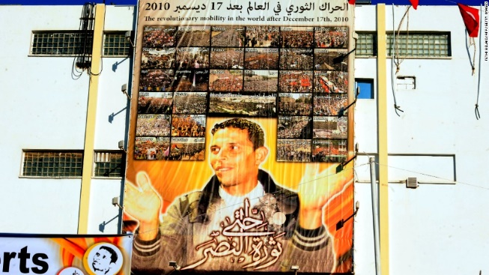
Figure 12: a portrait of Mohammed Bouaziz, displayed in his hometown

The Tunisian government’s response to the protests attracted international criticism when dozens of protesters were killed in clashes with police. A state of emergency was declared on 14th January 2011.

Within a month of Bouazizi’s death the autocratic president for more than 2 decades, Ben Ali, had fled to Saudi Arabia. He was replaced by a democracy that has endured terror attacks and economic troubles, serving as a beacon of hope to progressive intellectuals and activists in the region.

Tunisia is said to be the single success story of the Arab Spring, escaping the anarchy that fostered up in neighbouring countries opening the door to the prospect of freedom, yet, mostly ushering in the dismal spectres of repression, dictatorship, and ultimately fuelling the bloody rise of ISIS.

Terrorism: The country still struggles to control extremism, suffering two terror attacks in 2015, one being a mass shooting at a tourist resort were 38 people died and 39 were seriously injured.
- It was the deadliest non-state attack in the history of modern Tunisia.
- The tourism industry has been affected.
- Despite some improvements in border security, Tunisia has a porous border with Libya, where there’s a continuing conflict, an absence of security, and where Islamist terrorist groups operate, which is a significant threat.

GOVERNMENT
Tensions between Islamists, who wanted strict sharia as the main source of legislation and liberals at times appeared to threaten Tunisia’s transition to democracy, but, after more than two years of contentious negotiations, in January 2014 the Constituent Assembly voted overwhelmingly to approve a constitution that seemed to be acceptable to all sides.

Tunisia is now a unitary semi-presidential representative democratic republic. It is the only fully democratic sovereign state in the Arab world.

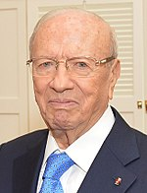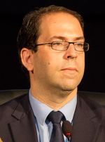
Figure 13: President Beji Caid Essebsi (left) and Prime Minister Youssef Chahed (right)

Tunisia is a representative democracy and a republic with a president serving as head of state, prime minister as head of the government, a unicameral parliament and a civil law court system. The president is directly elected for a five-year term and may be re-elected only once. Candidates for president must be Muslim, at least 35 years old, and Tunisian citizens by birth.

The president is the commander in chief of the armed forces and conducts foreign policy but cannot declare war or enter treaties without the approval of the Assembly of the People’s Representatives. The president can be impeached with a 2/3rds vote of the representatives.

Beyond political atrophy, progress is being made. Laws have been passed further criminalising violence against women. All forms of discrimination have been outlawed. And a bill is currently underway equalizing inheritance across the genders, a prospect unthinkable to most traditional minded religious heads.

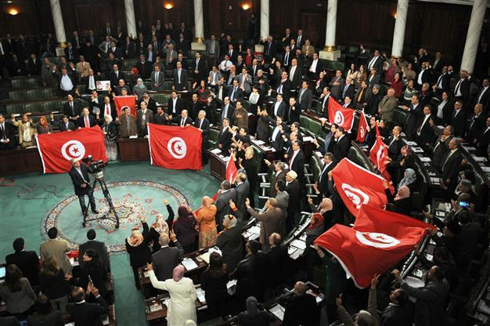
Figure 14: Tunisia’s parliament body is the Assembly of the People’s Representatives

Legal System: Tunisia’s legal system is based on French civil law with some influence from a liberal interpretation of Islamic law (Sharīʿah). The independence and neutrality of the courts are guaranteed by the constitution.

Gender Equality: Since independence, a prominent feature of Tunisian social policy has been the effort to improve the status and lives of women. The progressive Code of Personal Status, introduced in 1956, has been amended to affirm and enhance women’s political, social, and economic roles. The constitution adopted in 2014 guarantees the equality of men and women before the law. In 2017, Tunisia become the first Arab country to outlaw domestic violence against women, which was previously not a crime.

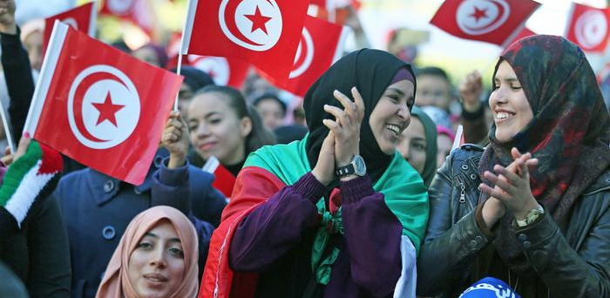
Figure 15: Compared with their counterparts in other Arab countries, women in Tunisia have enjoyed greater equality before the law.
INTERNATIONAL RELATIONS
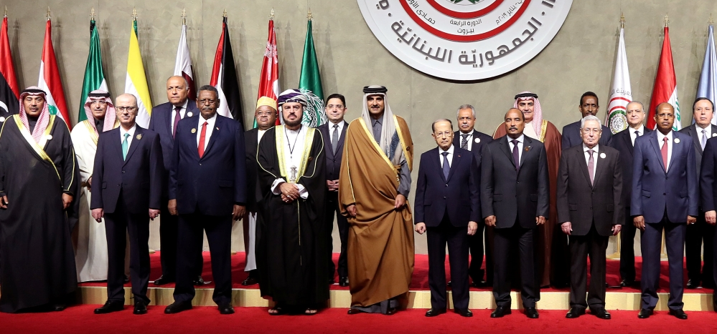
Figure 16: Arab leaders at the Beirut summit, 2019

Under Ben Ali, Tunisia followed much the same path. The need for regional security and the desire to advance economic interests, especially trade and foreign investment, guided foreign policy. With the uncertain future and stability of the Arab Maghrib Union, Tunisia increasingly concentrated efforts on developing bilateral economic agreements with other Arab states, on promoting the Arab League’s Arab Free Trade Area, and in advancing regional economics.

Tunisia has close relations with Europe, especially France and Italy, have been forged through economic cooperation, privatisation and industrial modernization. An agreement with the European Union, which came into effect in 1998, also tied Tunisia’s economy and security to the Mediterranean community.
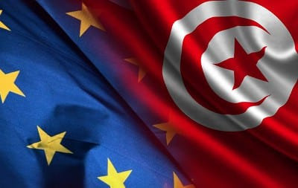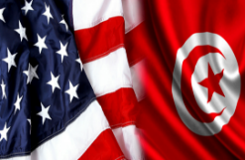
Figure 17 & 18: Tunisian flag corresponding with the USA and European Union Flag

Attempts to diversify trading links led to closer ties with the East and Southeast Asia, and strong ties with the USA remained essential in Tunisia’s ability to present itself as a stable, reliable, and moderate state. Tunisia obtained status of a major non-NATO ally of the USA.

Tunisia has been keen on supporting international organizations, in particular the United Nations, which it has viewed as the protector of smaller states and the defender of international law.

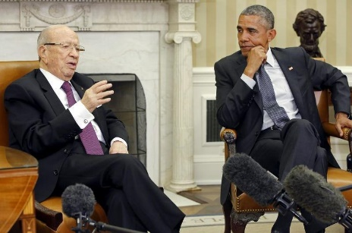
Figure 19: Tunisian President Beji Caid Essebs (left) with former USA President Barak Obama (right)
MILITARY SECURITY
As of 2008, Tunisia had an army of 27,000 personnel equipped with 84 main battle tanks and 48 light tanks.
The navy had 4,800 personnel operating 25 patrol boats and 6 other craft. The Tunisian Air Force has 154 aircraft and 4 UAVs.
Paramilitary forces consisted of a 12,000-member national guard. Tunisia's military spending was 1.6% of GDP as of 2006. The army is responsible for national defence and internal security.
Tunisia has participated in peacekeeping efforts in the DROC and Ethiopia/Eritrea. United Nations peacekeeping deployments for the Tunisian armed forces have been in Cambodia (UNTAC), Namibia (UNTAG), Somalia, Rwanda, Burundi, Western Sahara (MINURSO) and the 1960s mission in the Congo, ONUC.
The military has historically played a professional, apolitical role in defending the country from external threats. Since January 2011 and at the direction of the executive branch, the military has taken on increasing responsibility for domestic security and humanitarian crisis response.
MEDIA
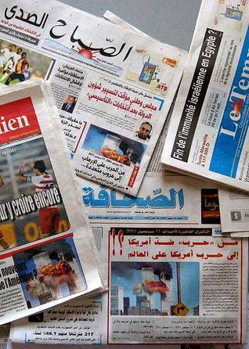
Until 2011 the Tunisian media operated under narrow constraints. Official censorship was augmented by self-censorship as various types of indirect government coercion restricted the ability of journalists and political personalities to speak freely.

Figure 20: Most the country’s daily newspapers are in French, and French-language television and radio programs are broadcast daily along with those in Arabic and Italian.

Nonetheless, the high rate of literacy and the sizable middle class helped to sustain an avid readership for the large number of periodicals (notably business and economics) published.

The number of citizens with access to satellite television and the Internet has grown considerably since the late 1990s, although the government under Ben Ali imposed what were believed to be among the world’s tightest restrictions on Internet use.

Pre-Tunisian Revolution:
- In 2008, in terms of Press Freedom, Tunisia was ranked 143rd out of 173.
- Even though freedom of press was formally guaranteed by the constitution, a critical approach to the president or the government in general, was suppressed.
- The media was dominated by state authorities through the Agence Tunis Afrique Presse.

Post-Tunisian Revolution:
- The media censorship by authorities has largely been abolished, and self-censorship has significantly decreased.
- There are several private media outlets representing a variety of political viewpoints.

Nonetheless, the current regulatory framework and social and political culture means that the future of freedom of press is still unclear.

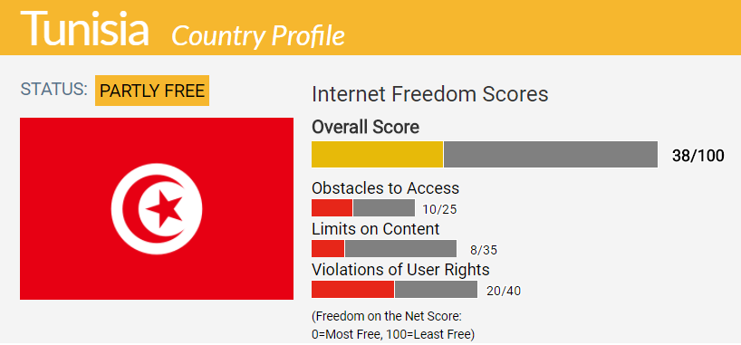
Figure 21: Tunisia received at 38 freedom of the net score. With 0 = most free.

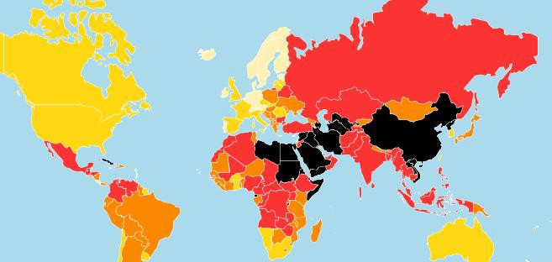
Figure 22: a map showing the rate of freedom of press in different countries in 2018, an investigation carried out by Reporters Without Borders, where the lighter the colour shows the higher the level of freedom

ECONOMY
GDP (PPP): $144.222 BILLION (2018 estimate)
GDP per capita: $12,369 (2018 estimate)

Gini (2017): 35.8 (medium)
HDI (2017): 0.735 (high, 95th)

Tunisia has a diverse economy. The economy depends heavily on mineral exports, especially petroleum and phosphates, a growing manufacturing sector (mainly made up of clothing and footwear, car parts and electric machinery) that has received much investment, and agricultural products. Tourism is also a significant source of revenue and foreign exchange, as are remittances from migrant workers living abroad.

Breakdown of GDP:
- Agriculture: 11.6%
- Industry: 25.7%
- Services: 62.8%
- Tourism: 7%

The economy fell into crisis in the early 1980s, the result of an overreliance on oil revenues, foreign aid, and labour remittances. In the mid-1980s a comprehensive program was introduced to liberalize the economy, which helped restore Tunisia’s international credit standing, stabilize public finances, reduce budget deficits and inflation, improve trade balances, and increase foreign and domestic investments.

While foreign debt has been brought under control, the country continues to suffer from a regional imbalance between the north and Al-Sāḥil region, which are more fertile and more economically developed, and the arid central and southern regions, which have fewer natural advantages.

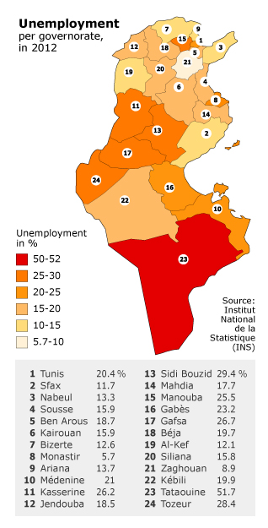
Figure 23: This map shows the stark difference of unemployment rates across the country.

Tunisia is an export orientated country in the process of liberalising and privatising an economy that, while averaging 5% GDP growth since the early 1990s, has suffered from corruption benefiting politically connected elites. As well as high unemployment especially among youth. Nonetheless, Tunisia was ranked the least corrupt North-African country in 2016.

Figure 24: A graph showing Tunisia’s annual GDP growth rate between 2008 and 2018.

In 2009 Tunisia was ranked the most competitive economy in Africa and the 40th in the World by the World Economic Forum. Tunisia has managed to attract many international companies such as Airbus and Hewlett-Packard.

The European Union (EU) remains Tunisia's first trading partner, currently accounting for 72.5% of Tunisian imports and 75% of Tunisian exports. Tunisia is one of the EU’s most established trading partners in the Mediterranean region and ranks as the EU's 30th largest trading partner. Tunisia was the first Mediterranean country to sign an Association Agreement with the EU, in July 1995, although even before the date of entry came into force, Tunisia started dismantling tariffs on bilateral EU trade. Tunisia finalised the tariffs dismantling for industrial products in 2008 and therefore was the first non-EU Mediterranean country to enter in a free trade area with EU.
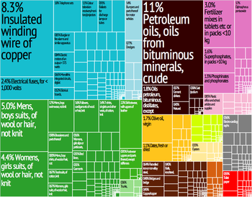Figure 25: Tunisia Export Tree map (2012)
Natural Resources: Petroleum was discovered in the south in 1964 and even though Tunisia’s deposits are much smaller than those of its larger neighbours, they are significant to the economy.

However, in the early 1990s Tunisia’s petroleum reserves were estimated to be enough to maintain the country’s low rate of extraction for several decades but insufficient to prevent Tunisia, because of increased domestic consumption and inadequate refinement facilities, from becoming a net importer of petroleum products.

Tunisia is self-sufficient in natural gas production, due to foreign investment. Tunisia also receives royalties on the gas that is pumped through a pipeline running through Tunisia, connecting the Algerian gas fields to Sicily.

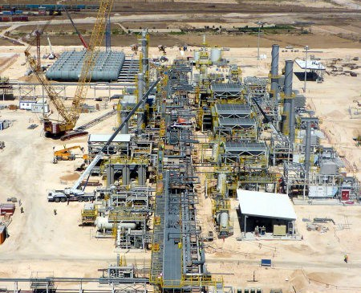
Figure 26: Nawara Gas Treatment Plant

Agriculture: Within North Africa, agriculture plays a relatively modest role in Tunisia’s economy. The agriculture sector accounts for 11.6% of the GDP and 16% of the country’s workforce.

- Principal Commodities: Olive oil, tomatoes, citrus fruit, grapes, dates, figs and almonds.
- Olive oil = $420,000,000
- Dates = $232,000,000
- Citrus = $9,000,000
- In 2017 agricultural exports to the USA totalled $88,000,000, over 90% of which included oil and dates.
- Tunisia supplies the USA with 30-40% of its imported dates and 5-10% of its imported olive oil.

2/3rds of Tunisia is suitable for farming and whilst larger agricultural enterprises are increasingly prominent, the sector remains politically sensitive and heavily regulated. Owing to deep-rooted cultural and trade ties, Tunisia has been heavily influenced by the European Union in agriculture policy.

Tunisia also maintains significant market controls in place throughout the agriculture value-chain, which to some extent, limit growth and investment opportunities. For example, public land may be leased from the government to private farmers or managed directly by the Ministry of Agriculture. Foreigners cannot own agricultural land but may obtain long-term leases. Small farms, in turn produce low-crop yields, which is impacted further by periodic drought and sporadic rainfall, which often jeopardises harvests.

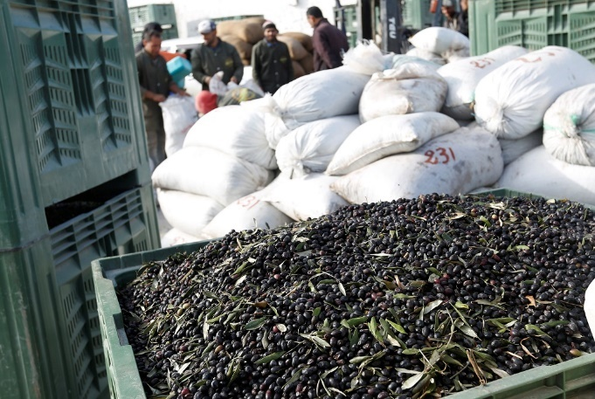
Figure 27: Olives are a fundamental commodity to Tunisia’s export industry

Tunisia is the biggest Olive Oil producer outside the European Union, 4th behind Spain, Italy and Greece. The Sahal, a broadening coastal plain along Tunisia’s eastern Mediterranean coast, is among the world’s premier areas of olive cultivation. The oldest Tunisian olive tree, which is over 2,500 years old, is in Echraf; its roots cover 16m² and its trunk has a 6m circumference.

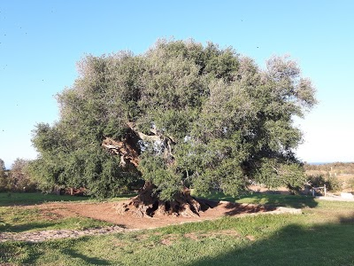
Figure 28: This olive tree transcends the limits of time thereby conveying the message of hope, vitality and strength

Manufacturing: Manufacturing contributes roughly 1/6th of GDP and employs an equal proportion of the population.

The development of manufacturing in Tunisia has historically encountered two major difficulties: raw material and power supplies are inadequate, and the domestic market is limited. In general, the manufacturing base has remained relatively small and overly concentrated on making clothes, textiles, leather goods, and food products.

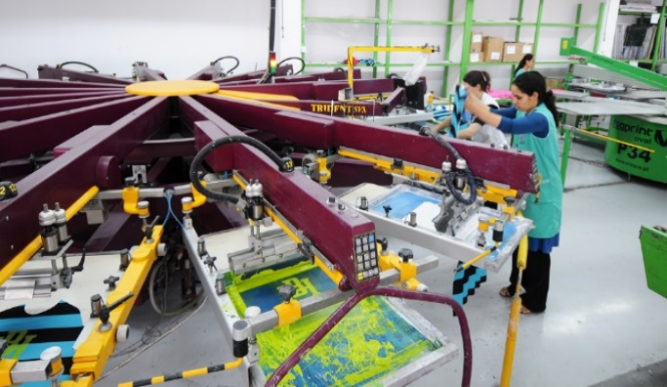
Figure 29: A modern clothing factory

As a result of reforms, Tunisian manufacturing has become much more diversified, with new investments in the production and export of mechanical and electromechanical equipment, petroleum products, and chemicals. The textile sector remains disproportionately large, however, and more than one-third of all manufacturing operations are in Tunis alone. On the other hand, investment codes introduced in the late 1980s have attracted strong foreign interest, which has enhanced technology transfer, modernized the service and financial sectors, and aided export development.

Privatization has been a slower process. After an initial flurry of sales in the early 1990s, the pace slackened, and privatization seemed restricted to small, profitable enterprises such as textile factories. There have been renewed efforts to expand the private sector by transferring ownership of large, strategic companies, and activity has increased, particularly involving foreign interests.

Trade: Tunisia’s most significant exports are textiles and leather products, electrical machinery, and crude and refined petroleum. Its major imports are consumer products, raw materials, machinery and electrical equipment, and food products.

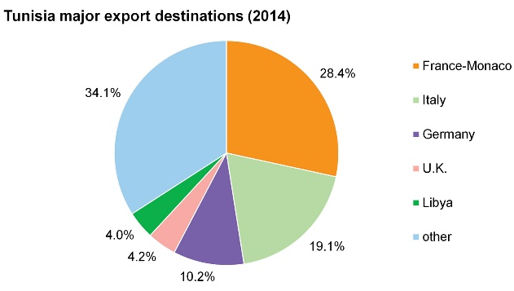
Figure 30: A pie chart showing the main export destinations Tunisia trades with

- Exports in Tunisia rose 21.9% every year to TNT 3,815,500,000 in January 2019.
- Increases in shipments were seen for mining products, phosphates and related (74%); other manufactured products (46.6%); mechanical and electrical products (29.6%); energy & lubricants (18%) and textiles, clothing & leather (16.3%).

Tunisia is a net importer of agricultural products. In 2017, leading agricultural imports were:
- Wheat = $432,000,000
- Sugar = $284,000,000
- Vegetable oils = $263,000,000
- Corn = $216,000,000
- Soybeans = $192,000,000
- Barley = $110,000,000

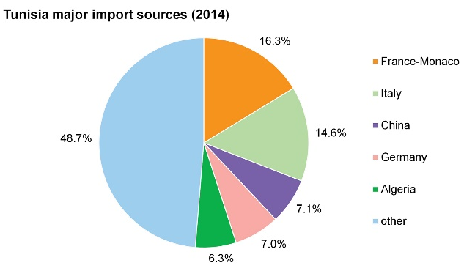
Figure 31: A pie chart showing the main export destinations Tunisia trades with

- Imports to Tunisia surged 24 percent year-on-year to TNT 5383.8 million in January 2019.
- It was boosted by higher purchases of capital goods (38.8%); energy products (26.6%), namely natural gas (62.1%) and refined petroleum products (14%); and raw materials (10.4%)
.
Tunisia applies an average import duty of 32% on U.S. agricultural exports, which in 2015-17, averaged $160,000,000. In 2017, U.S. agricultural exports to Tunisia were in total $125,000,000 with soybeans and corn oil accounting for over 85% of the total.
Services: Services, including retail trade, public administration, defence, and tourism, account for a significant portion of GDP and for nearly half of employment.

Tourism in Tunisia is an industry that generates around 8 million arrivals per year, which makes the country among the ones that attract the most tourists in Africa. Tunisia has been an attractive destination for tourists since the beginning of the 1960s.
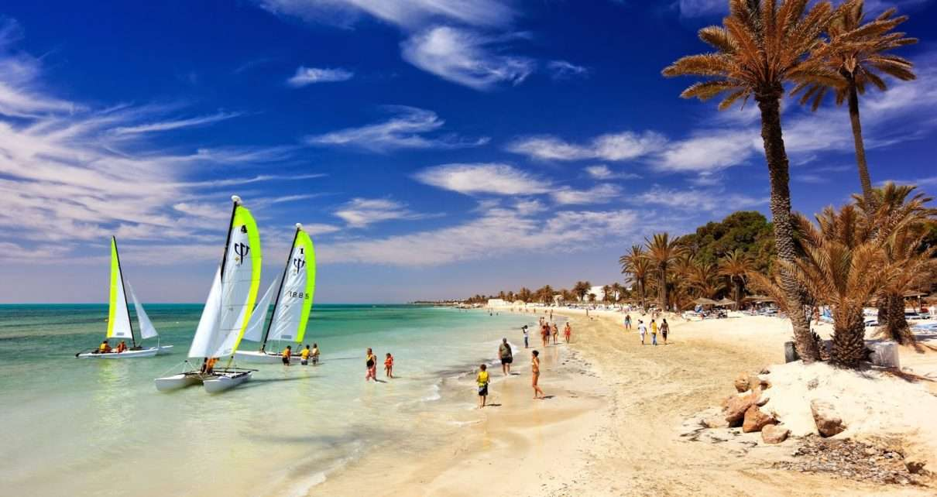
Figure 32: Tunisia is highly popular for its beaches and costal tourist towns.

Among Tunisia's tourist attractions are its cosmopolitan capital city of Tunis, the ancient ruins of Carthage, the Muslim and Jewish quarters of Jerba, and coastal resorts outside Monastir.
According to The New York Times, Tunisia is "known for its golden beaches, sunny weather and affordable luxuries."

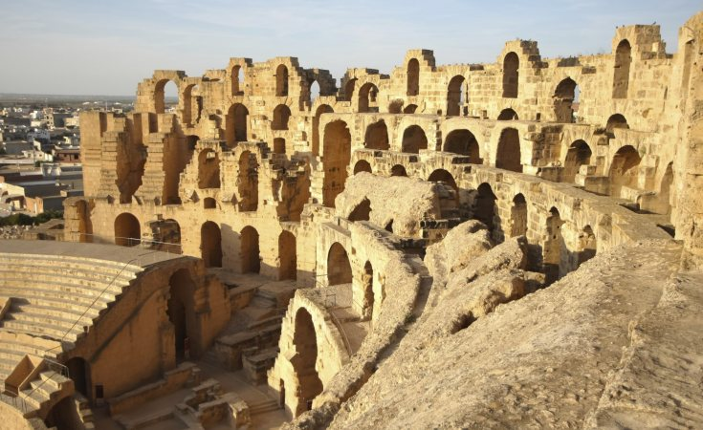
Figure 33: Archaeological site of Carthage

DEVELOPMENT: TUNIS
- Tunis Sports City is an entire sports city currently being constructed in Tunis, Tunisia. The city that will consist of apartment buildings as well as several sports facilities will be built by the Bukhatir Group at a cost of $5,000,000,000.
- The Tunis Financial harbour will deliver North Africa's first offshore financial centre at Tunis Bay in a project with an end development value of $3,000,000,000.
- The Tunis Telecom City is a $3,000,000,000 project to create an IT hub in Tunis.
- Tunisia Economic City is a city being constructed near Tunis in Enfidha. The city will consist of residential, medical, financial, industrial, entertainment and touristic buildings as well as a port zone for a total cost of $80,000,000,000. The project is financed by Tunisian and foreign enterprises.

CONCLUSION
Modern Tunisians are the descendants of indigenous Berbers and of people from numerous civilizations that have invaded, migrated to, and been assimilated into the population over the millennia.

Tunisia is home to the ancient city of Carthage, and modern metropolitan city if Tunis, which has a significant financial district. Tunisia is an important player in the Mediterranean, thanks to its location in the centre of North Africa, close to vital shipping routes.

Starting from independence, President Bourguiba placed strong emphasis on economic and social development, especially education, the status of women, and the creation of jobs, policies that continued under Zine El Abidine Ben Ali's administration.

The result was strong social progress – high literacy and school attendance rates, low population growth rates, and relatively low poverty rates – and generally steady economic growth. These pragmatic policies have contributed to social and political stability.

Tunisia is now said to be the only fully democratic sovereign state in the Arab world.

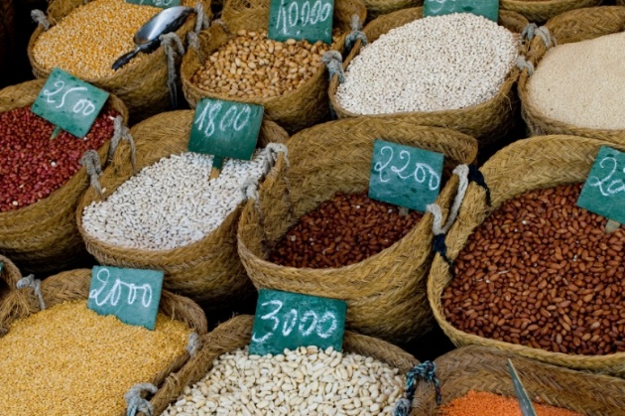

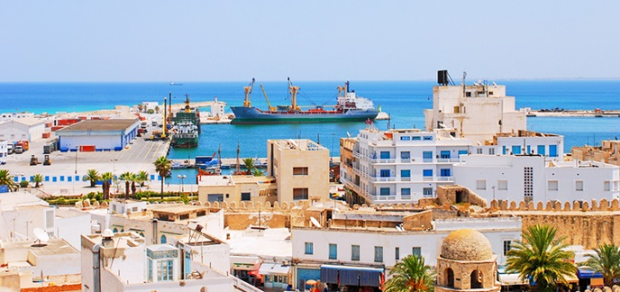

BIBLIOGRAPHY

https://www.export.gov/article?id=Tunisia-Agricultural-Sector

http://www.tunisia-oliveoil.com/En/

https://tradingeconomics.com/tunisia/food-imports-percent-of-merchandise-imports-wb-data.html

https://wits.worldbank.org/CountryProfile/en/Country/TUN/Year/LTST/TradeFlow/Import/Partner/by-country/Product/16-24_FoodProd

https://www.indexmundi.com/trade/imports/?country=tn

https://www.indexmundi.com/trade/exports/?country=tn

https://atlas.media.mit.edu/en/

https://tradingeconomics.com/tunisia/imports

https://www.independent.co.uk/voices/arab-spring-anniversary-tunisia-protest-uprising-mohammed-bouazizi-middle-east-a8687196.html

https://edition.cnn.com/2013/10/30/world/tunisia-fast-facts/index.html

https://fanack.com/tunisia/

https://www.worldscapitalcities.com/capital-facts-for-tunis-tunisia/

https://www.desertcampmorocco.com/blog/post.php?s=2015-10-26-10-interesting-facts-about-berbers

http://www.tourismtunisia.com/the-language-in-tunisia/

https://www.tripsavvy.com/tunisia-travel-information-1454625

https://www.britannica.com/place/Tunisia/Resources-and-power
https://www.aljazeera.com/news/2019/01/beirut-summit-leaders-agree-29-item-economic-agenda-190120180407191.html

https://en.wikipedia.org/wiki/Tunisia

https://www.bbc.co.uk/news/world-africa-14107241

