The Suez Canal

History - Construction

In 1854, Ferdinand de Lesseps reached an agreement with the Ottoman governor of Egypt to build a canal that would connect the Mediterranean and Red Sea.

The purpose of the canal was to reduce the sailing route between Europe and Asia and thus the time taken for sea travel between the two continents, in effect its purpose was to render the protracted shipping lane around the Cape of Good Hope obsolete.

The construction of this waterway was conducted by the Suez Canal Company between 1859-1869.

Estimates state over 1.5m people were employed throughout the Canal’s decade-long construction, using both forced and hired labour. Between 120,000 and 130,000 workers are believed to have died in its construction.

The first ship to officially pass through the canal was the Imperial yacht L’Aigle with Empress Eugenie of France onboard, however the HMS Newport was in fact the first vessel to travel through the canal, promoting British interests after British opposition to the Canal.

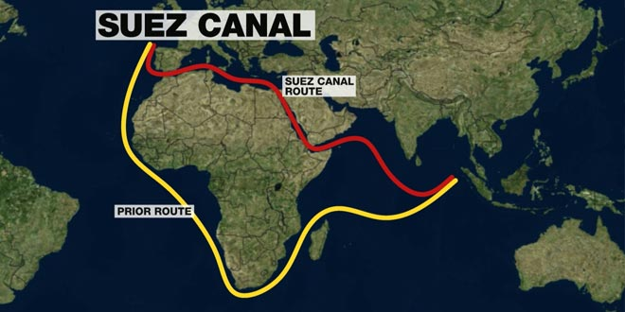
Opened in November 1869, the Suez Canal revolutionised sea trade between Europe and Asia.

The distance between London and Mumbai has been reduced by around 42% (when measured in nautical miles).

This fostered an expansion in international trade that has continued to the present day.
1.World map highlighting the reduction in nautical distance between Asia and Europe.

History – The Suez Crisis

On 26th July 1956, Egyptian President, Gamel Abdel Nasser, nationalised the Suez Canal, which had been owned by the Suez Canal Company operating for British and French interests.

The decision to nationalise the canal came because of strengthening relations between Egypt and the Soviet Union including the trading of weapons. This culminated with the Americans and British choosing to withdraw funding for the construction of the Aswan Dam.

The British and French feared the closure of the Suez Canal and hence the haemorrhage of petroleum from the Persian Gulf and as such allied with the Israelis when diplomacy failed.

Israeli forces invaded Egypt in October 1956 and, enforcing their plan, the British and French demanded the withdrawal of Egyptian and Israeli troops from the canal, occupying the canal zone themselves by 6th November to supposedly enforce a cease-fire.

This move was met by stern opposition by the US, resulting in the removal of British and French troops by December 1956 and Israeli troops by March 1957.

Control of the Suez Canal was given to the Suez Canal Authority – a public and independent body that manages the canal.

The Suez crisis was the first of only two contemporary closures enforced on the canal, the second of which was during and beyond the third Arab-Israeli war from 1967 and was reopened after the signature of the second disengagement accord.

Suez Canal Expansion PRoject

In 2014, plans were announced to expand and deepen parts of the canal while also facilitating two-way traffic along part of the route through the $8.2bn construction of a new 35km long shipping lane.

The aim of the project was to triple revenues and increase vessel traffic by 2023.

At least 2,000 people have been displaced by the expansion, with residential buildings destroyed and agricultural land seized.

Construction was finished in 2015 and results have since been mixed. (See appendix 1 for more statistics).

Revenues in the first quarter of 2016 were similar or lower than the same period in the previous year (when measured in dollars).

There have also been incidents of vessel grounding. Most recently, the containership Aeneas and bulk-carrier Panamax Alexander ran aground in July 2018, resulting in traffic chaos.

However, the canal has seen an increase in traffic, with 14,486 ships through the canal between January and October 2017, up from 14,053 ships through the same period in 2016

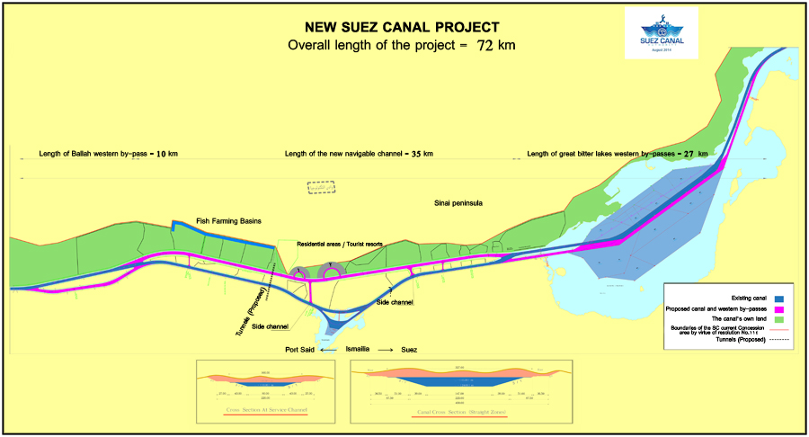
Mohab Mamish, the head of the Suez Canal Authority, has also claimed that the Canal received record revenues for the fiscal year of 2017-18, up 13% on the previous year.
2. A bird’s eye plan outlining the Suez Canal expansion

Suez canal economic zone

The Suez Canal Economic Zone (SCEZ) complements this expansion, providing potential investment opportunities, advanced technology and vast infrastructure within its 461km² area.

The SCEZ incorporates 4 ports – West Port Said Port, Adabiya Port, Al Tor Port & Al Arish Port.

This is augmented by a variety of incentives when conducting business within the SCEZ, including the exemption of imports from customs duties and sale tax and fast-track visa services.

In conjunction, companies can take advantage of a variety of trade agreements, such as GAFTA, the Egypt-EU partnership agreement and the Agadir Agreement among others.

This has attracted several foreign firms, such as Kuwaiti logistics firm Agility, to relocate within the zone.

The SCEZ is targeting specific sectors to operate within their parameters:

Ports and logistics – investment potential in Ain Sokha Port and East Port Said Port

Maritime services – traffic through the isthmus lends itself to maritime related activity, such as ship repairs

Industry – vast land areas for all industry

Renewable energy – strong solar and wind farm potential

Vallis current and past Operations in the Suez Canal

On 9th July 2018, Vallis began a CMA operation with one of the front runners in Egypt’s feedstuff and grains market, located to the east of Cairo.

In the past, Vallis has also been seen in Sokhna. This was a CMA for coal with a bulk commodity trader

Vallis has been present in Port Said, in the far north of the Suez Canal, with a global food production company.

Appendix

Appendix 1 – detailed Canal statistics

Oil and oil-based products dominate this, accounting for 24.23% of all cargo that passed through the canal in 2017, of which crude oil is the biggest contributor at 106,180 thousand tons (Suez Canal Authority).

A total of 17,550 vessels passed through the canal last year and this was dominated by North/South traffic which saw a 19.3% increase in 2017.

Trade involving South-East Asia and the Arabian Gulf saw the most cargo pass through the canal (282,300 and 251,180 thousand tons respectively).

The 2017/18 fiscal year saw a total of 942,370 thousand tons of cargo travel across the canal.

The most common ships passing through the canal are container ships and tankers, accounting for 31.73% and 25.85% of all ships in 2017.

