VALLIS GROUP lIMITED – COUNTRY REPORT

IRAQ

nOVEMBER 2020
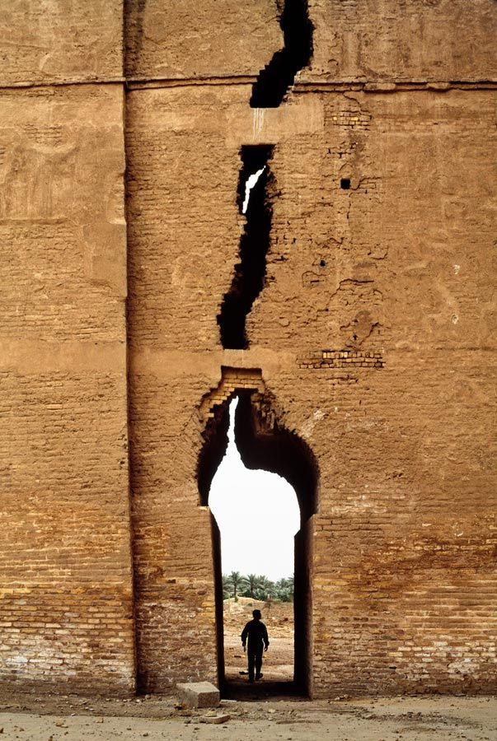

Introduction

Official Name: The Republic of Iraq
Capital City: Baghdad
Location: 33 00 N, 44 00 E
Population: 38,872,655 (July 2020)
Land: 437,072 sq. km
Water: 950 sq. km
Currency: Iraqi dinars (IQD)
GDP (per capita): $16,700
Dominant religion: Muslim (95%), Christian (1%), Other (4%)
Languages: Arabic, Kurdish (official), Turkmen, Syriac, Armenian (only official in some areas).

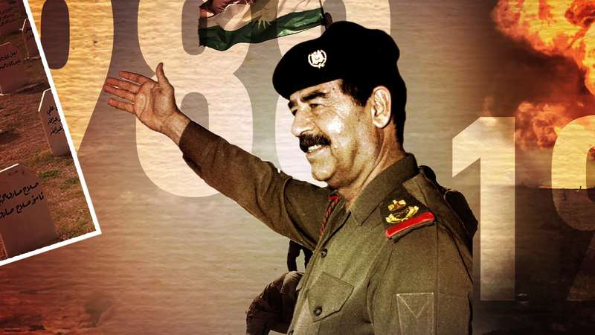
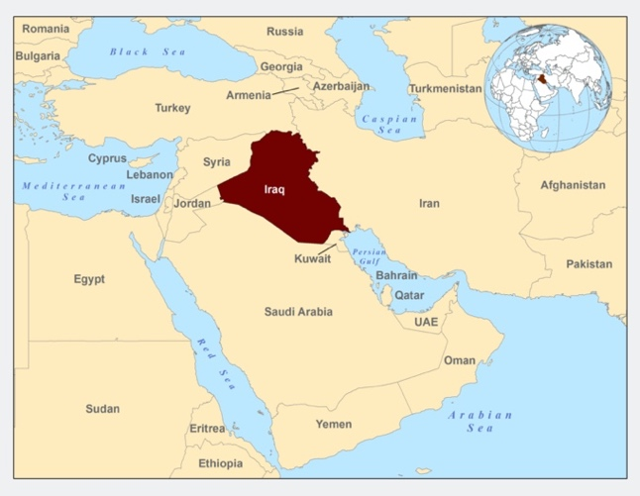
Iraq is located in the Middle East, bordering the Persian Gulf, and sharing borders with Iran, Jordan, Kuwait, Saudi Arabia, Syria and Turkey.
Figure 1. Map showing Iraq in red – from https://www.cdc.gov/immigrantrefugeehealth/profiles/iraqi/background/index.html
History and governance
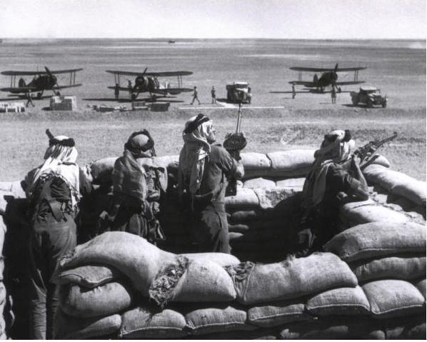
The Kingdom of Iraq was formed in 1932. Having been occupied by the United Kingdom during World War I, it remained a United Nations (UN) mandate under the control of the UK for the next 12 years. Prior to the war, Iraq was part of the Ottoman Empire.

Figure 2. The Anglo – Iraqi War – from http://histomil.com/viewtopic.php?t=7562
In 1941, a coup d’état was staged, leading to the Anglo-Iraqi war. Fearing that Iraq might refuse to supply the allies with oil, the UK invaded again. In under a month, an armistice was reached, although the occupation did not end until 1947, with some UK forces only leaving in 1954.
Another coup d’état occurred in 1958, this time anti-imperial and anti-monarchical, which eventually led to the formation of the Republic of Iraq. For the next two decades, Iraq was ruled by a series of leaders, until February 1963, when a further coup d’état took place with the support of the Ba’ath Party. After a prolonged period of political turbulence, Saddam Hussein, leader of the Ba’ath Party, took power in 1979.
Figure 3. Saddam Hussein – from https://www.britannica.com/biography/Saddam-Hussein
Following the Iranian Revolution in 1979, Iraq declared war on Iran. The 8-year war that followed involved the use of chemical weapons by Saddam Hussein on multiple occasions, including against Iraqi Kurds, with 50,000 – 100,000 people believed to have died. After significant losses on both sides, a peace agreement was reached.
In August 1990, Iraq invaded Kuwait. UN forces, led by the US, fought in the Gulf war of 1991 to successfully expel Iraqi forces. Following this, the UN Security Council (UNSC) ordered Saddam to destroy all weapons of mass destruction and long-range missiles. In the aftermath of 9/11 and following claims that Iraq had not complied, the US put together a coalition to invade, starting the Second Gulf War in 2003, which led to Saddam being ousted, and his subsequent trial and execution. The weapons of mass destruction were never found.
In 2005, a Council of Representatives (COR) was formed. The international community played an active role in supporting the Iraqi government during this period. US and coalition forces began to withdraw in May 2007, withdrawing completely in June 2009.
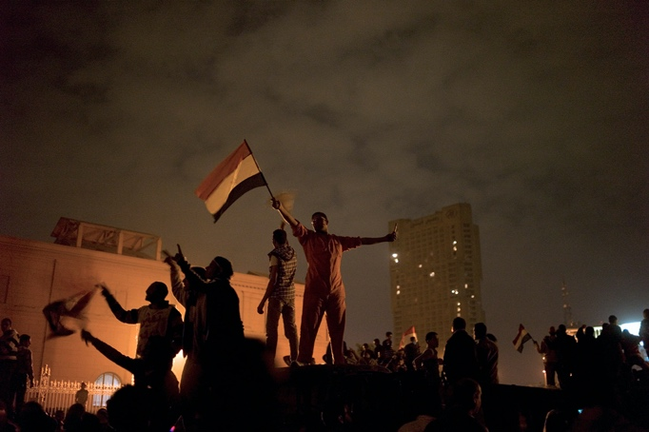
Between 2011 and 2019, Iraq has experienced varying levels of instability. February 2011 included protests as part of the Arab Spring. In 2012 and 2013, Iraqi civilians were motivated to join the Syrian Civil War, crossing over the border. With the unforseen emergence of the Islamic State of Iraq and the Levant (ISIL), forces took control of various large cities in 2013, including Tikrit, Fallujah and Mosul. Internal conflict between Sunni, Shiite and Kurdish groups has led some to campaign for the creation of three autonomous regions within Iraq.
Figure 4. The Arab Spring in Iraq – from https://www.nytimes.com/2013/04/07/opinion/sunday/the-arab-spring-started-in-iraq.html
Between 2014-17, the Iraqi Civil War was fought against ISIS. Many other nations including the US took part. By December 2017, ISIS had lost all territory in Iraq.
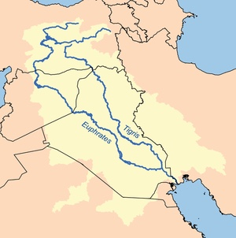
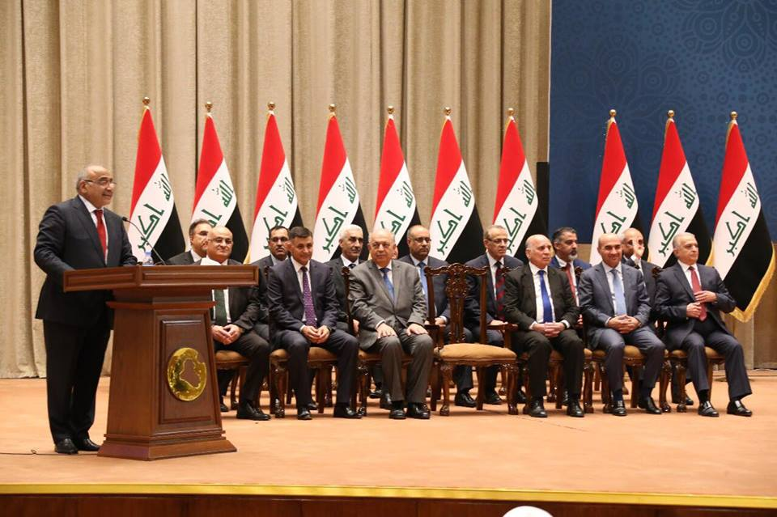
In September 2017, a referendum for Kurdish independence held by the Kurdistan Regional Government was voted for by 92% of Iraqi Kurds. This election was deemed illegal and overturned by the federal government.
Figure 5. The Iraqi government – from https://gds.gov.iq/first-report-on-implementation-of-iraqi-government-programme-2018-2022/
The current government defines itself as a democratic, federal parliamentary republic. Whilst Iraq has improved in terms of political instability, corruption is rife, with Transparency International putting Iraq as the 8th most corrupt government in the world.
Climate and geography
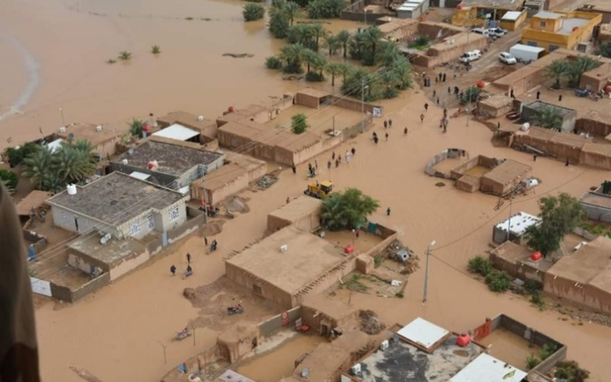
The climate in Iraq is mostly desert-like with temperatures ranging greatly between winter and summer. Despite minimal rainfall in the country overall, the northern mountainous regions can experience heavy snowfall. This can lead to flooding in central and southern Iraq.
Figure 6. Flooding in Iraq– from http://floodlist.com/asia/iraq-floods-november-2018
Iraq consists mainly of broad plains. The south border with Iran is marshland, with large areas of flooding. The northern borders with Iran and Turkey are mountainous. The Tigris and Euphrates rivers carry around 60,000,000 m³ of silt to the surrounding areas, creating some fertile land.
Figure 7. The two main rivers in Iraq– from https://en.wikipedia.org/wiki/Tigris
As described above, minimal land is arable. Just under 1/5 of the land is used agriculturally, with 8.4% arable, 9.2% permanent pasture and 0.5% permanent crops. 1.9% of land is forest.
Demography

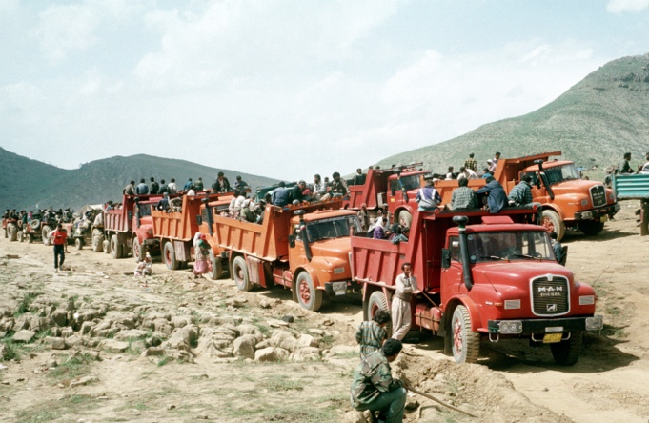
The CIA World Factbook uses data from a 1987 estimate by the Iraqi government to state that 75-80% of Iraqis are Arabs, with 15% Kurds. The remaining 5% consists of minorities, including Assyrians, Turkmen, Yezidis, Shabak, Kaka’I, Bedouins, Roma, Circassians, Sabaean-Mandaean and Persians. This data is suspected to be inaccurate with regards to minorities, as citizens were required to identify as Arabic or Kurdish. The Turkmen population is likely to be significantly higher than recorded.

The vast majority of the population is Muslim. Within the Muslim population, the Shia group (55-60%) is larger than the Sunni group (40%). The next largest group, whilst a minority, is Christian (1%). The Christian population has decreased substantially since the deposition of Saddam Hussein.

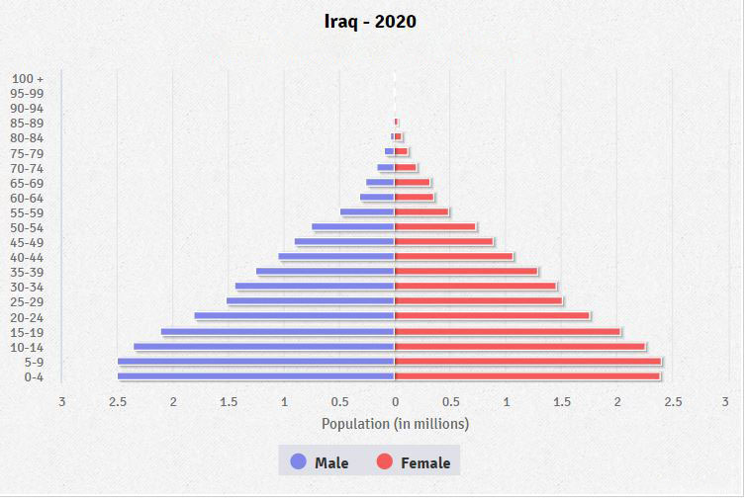
Figure 8. Age of Iraq’s population as of 2020 – from https://www.cia.gov/library/publications/the-world-factbook/geos/iz.html

Figure 8 shows the age structure in Iraq. 37% of the population is under 14. Nearly 20% is between 15 and 24 years old. 36% of people are between 25 and 54 years old. Only 7% of the population is aged greater than 55. Until the age of 55, the ratio of men to women is very equal. Between 55 and 65 there are slightly more women, and the over 65 category contains 25% more women than men. The median age is 21.2 years.

The majority of the population is found in the north, east and centre of Iraq, particularly alongside the Tigris and Euphrates Rivers. The west and south are largely uninhabited.

The Iraqi diaspora describes the mass movement of Iraqi citizens to other countries. In 2003, nearly 2 million Iraqis are estimated to have migrated elsewhere during the Second Gulf War. In 2007, 1.9 million are estimated to have moved within Iraq to avoid conflict. The UN stated that 40% of middle class Iraqis fled before 2007, citing an escape from persecution as their reason. Around 46,000 migrants are believed to have returned later in 2007.
Figure 9. Migrants in Iraq– from https://en.wikipedia.org/wiki/Refugees_of_Iraq
Health

- Birth rate: 25.7 births per 1,000 population
- Death rate: 3.9 deaths per 1,000 population
- Maternal mortality rate: 79 deaths per 100,000 live births
- Infant mortality (male): 20.9 deaths per 1,000 live births
- Infant mortality (female) 18.2 deaths per 1,000 live births
- Life expectancy (male): 70.7 years
- Life expectancy: (female): 74.6 years
- Fertility rate: 3.39 children born per woman
- Physicians density: 0.84 physicians per 1,000 population
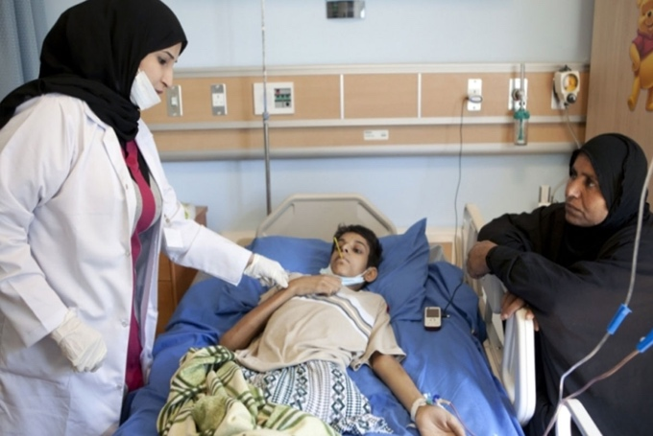
- Hospital beds: 1.2 beds per 1,000 population
Figure 10. Inside a hospital in Iraq– from https://www.middleeastmonitor.com/20160125-iraq-cancels-free-healthcare-system/
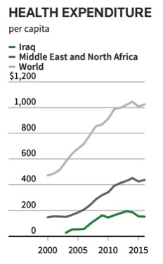
The health care system in Iraq used to be fairly advanced. 6.84% of Iraq’s GDP was spent on healthcare. Unlike other poorer countries, which use mass health care with primary care practitioners, Iraq’s health care is based on specialist medical practitioners working in well funded hospitals. In 1990, 97% of urban citizens and 71% of rural citizens had access to free healthcare.
Figure 11. Health expenditure– from https://www.reuters.com/investigates/special-report/iraq-health/
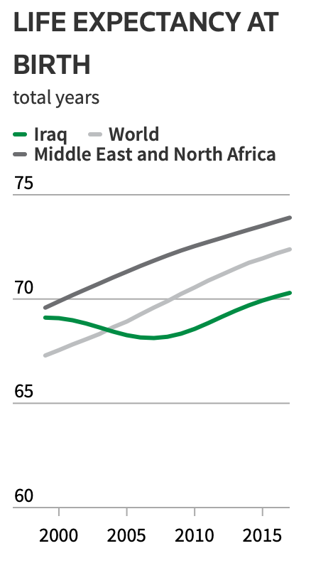
Over the past three decades, the healthcare system has been severely damaged. In 2019, only 2.5% of GDP was spent on healthcare, compared to 18% on security. This has translated to a far lower expenditure per capita than other Middle Eastern countries (shown above).

“Health is not a priority and the indicators show that. The government did not give healthcare what it deserves.” – Alaa Alwan, Health Minister for Iraq

Due to the lack of funding, treatable diseases such as cancer are being left untreated. This adds to diseases which are commonplace, such as bacterial diarrhoea, hepatitis A and typhoid fever. In 2018, over 85% of essential drugs were either hard to obtain or unavailable. The State Company for Drugs Industries (SDI) is now producing 80% fewer medications than in 2002. Plants used for drug production have been destroyed, and funds are diverted through corruption, preventing repairs and expansion.

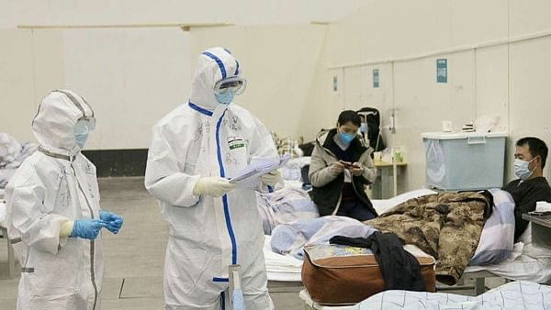
There is also a shortage of doctors and nurses. Since Saddam Hussein’s deposition, 320 doctors have been killed in the resulting conflict. There are 20,000 fewer doctors than in 1990. In addition to this, in 2016, Iraq cancelled free healthcare, with patients asked to pay fees to cover basic treatment. The COVID-19 pandemic has amplified existing problems within the health system.
Figure 12. Coronavirus cases in Iraq– from https://www.nationalheraldindia.com/international/iraq-confirms-first-novel-coronavirus-death-health-official

Life expectancy has fluctuated throughout the past few decades (see below). Decreasing from 71.3 years in 1996, to 68.5 in 2010, it has now risen back up to 72.6. This is in contrast with the rest of the world, where life expectancy has consistently risen.

Figure 13. Life expectancy at birth– from https://www.reuters.com/investigates/special-report/iraq-health/

Education and employment

60% of jobs in Iraq are in the public sector, with 2/3 of this number working directly for the government. Unemployment estimates range from 16 – 30%. Almost twice as many women as men are unemployed. The oil industry, whilst responsible for the majority of revenue, provides only 1% of employment for the population. Youth unemployment is higher, although it has decreased from 30% in 2008 to 22.8% in 2011.
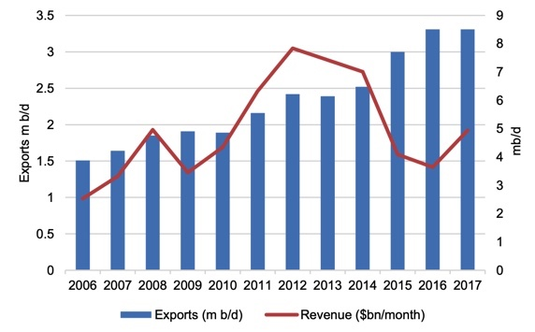
Figure 14. Oil exports from Iraq – from https://fred.stlouisfed.org/series/SLUEM1524ZSIRQ

A minimal number of women form part of the labour force. Only 7% of non-agricultural jobs are performed by women, although the percentage of women in such roles had risen from 12.1% in 2008 to 14.7% in 2011. The majority of women (88%) are not seeking employment, due to factors such as violence, traditional societal beliefs and lack of support from the government.

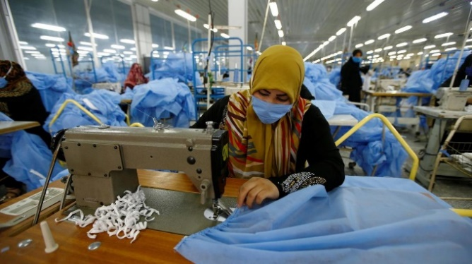
Figure 15. Women in the workplace – from https://www.thenational.ae/business/economy/covid-19-blow-to-female-workforce-in-iraq-jordan-and-lebanon-1.1039659

The quality of education varies across Iraq. 1/5 of Iraqis aged 10 – 49 years are illiterate, with twice as many women illiterate than men. Enrolment in primary education increased from 76.3% in 2000 to 89.1% in 2011. However, overall enrolment decreased to 85% in 2007, particularly affecting girls in rural areas, where 30% were not enrolled. In 2016, nearly 3.2 million children were not in school.

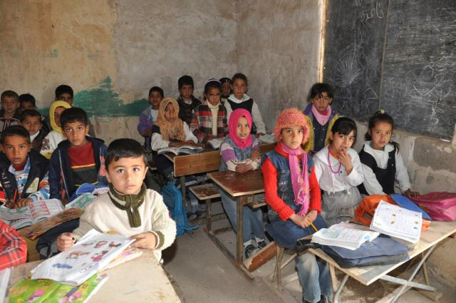
One of the problems in education is the damage to infrastructure. Half of all schools in Iraq have sustained serious damage. In an effort to combat this, some schools run more than one shift per day, with different students at different times. The pass rate of morning students is 92%, whilst the pass rate of students on the evening shift is 72%.
Figure 16. Education in Iraq – from https://news.artnet.com/art-world/isis-cuts-art-music-and-history-education-in-iraq-103714

Another issue is the lack of funding. Iraq only allocates 6% of its national budget to education, ranking at the bottom of all Middle Eastern countries.

Economy

- GDP – $649.3 billion
- GDP per capita – $16,700
- Inflation rate – 0.1%

GDP composition, by sector:
- Agriculture – 3.3%
- Industry – 51%
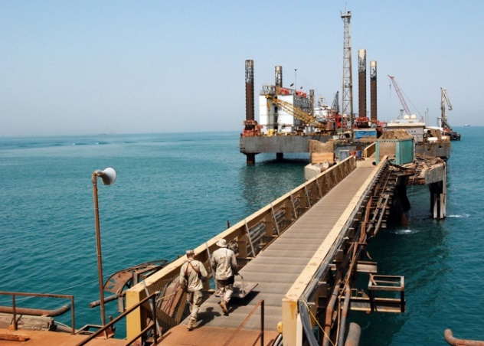
- Services – 45.8%
Figure 17. An oil platform – from https://en.wikipedia.org/wiki/Economy_of_Iraq
Iraq’s economy is largely dominated by oil. The oil industry accounts for 85% of government revenue and between 80 – 95% of foreign exchange earnings. 82% of government investment in 2018 was related to oil.

Other industries include petroleum, chemicals, textiles, leather, construction materials, food processing, fertilizer, metal fabrication, and agriculture, particularly wheat, barley, rice, vegetables, dates, cotton, cattle, sheep and poultry.

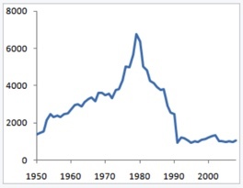
As mentioned above, Iraq has been badly hit by the recent conflict and instability. Between 1990 and 2005 the GNP per capita decreased to levels not seen since before 1950 (see below). Since 2010, it has risen back to almost $6,000.
Figure 17. GNP per capita in Iraq from 1950 to 2008 – from https://en.wikipedia.org/wiki/Iraq#Economy

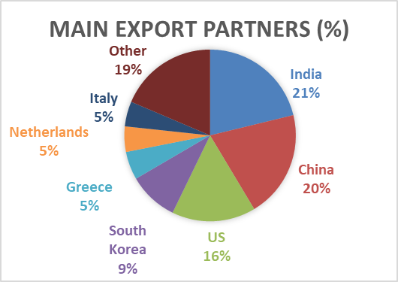
Exports in 2017 were worth $61.4 billion. They consisted of crude oil (99%), crude materials excluding fuel, food and live animals. The below chart shows the main export partners.
Figure 18. Main export partners – from https://www.cia.gov/library/publications/the-world-factbook/geos/iz.html

The main imports for Iraq were food, medicine, and manufactures. The total value was $39.47 billion. The below chart shows Iraq’s main import partners.

In 2020, Iraq’s economy contracted 5%. This was due to several factors. Firstly, international oil prices significantly decreased. Secondly, COVID-19 has caused considerable global disruption in most industries. The discrepancy between expected budget and actual budget will lead to a “severe financing gap” which will be funded by the Central Bank of Iraq and State-Owned Banks. Unfortunately, this will only increase Iraq’s economic vulnerability.

The oil industry

Iraq has always been a major country in the global oil industry. One of the founding members of the Organization of Petroleum Exporting Countries (OPEC), its natural supplies of 12% of global oil are second only to Saudi Arabia. Oil exports in August 2017 were 3.6 million barrels per day, rising to 3.9 million per day in 2019. In monetary terms, exports were worth $82.3 million in 2019. The oil industry is crucial within Iraq, providing 90% of government revenue.

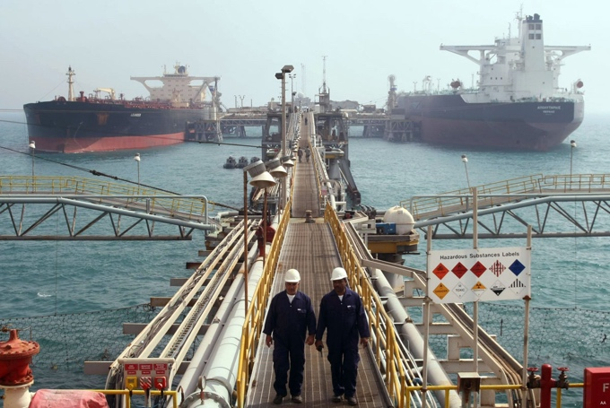
Figure 20. Oil tankers in Iraq – from https://www.middleeastmonitor.com/20200606-iraq-confirms-full-compliance-with-crude-oil-production-cuts/

Oil production has fluctuated since 1980. In 1979, Iraq was producing 4.0 million barrels per day. The war with Iran severely damaged Iraq’s oil industry. $120 billion was lost in GDP, with $33 billion worth of infrastructure destroyed. By 2003, the yield had decreased to 2.7 barrels per day. Over the next ten years, it varied between 0.5 – 2.0 million barrels per day.

More recently, oil production has dramatically increased, particularly since the defeat of ISIL in 2017. August 2019 saw record levels of production, with 4.88 million barrels per day.
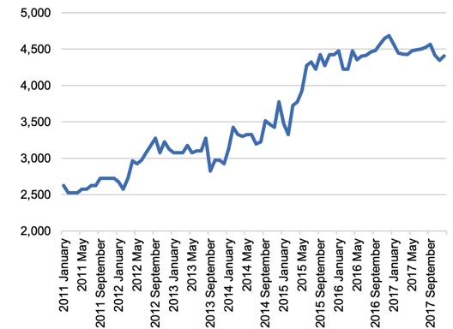
Figure 21. Oil production in Iraq – from https://www.oxfordenergy.org/wpcms/wp-content/uploads/2018/10/Iraqi-Oil-industry-evolution-and-short-and-medium-term-prospects-WPM-79.pdf

The same pattern has been seen with exports. Whilst revenue has fluctuated for other reasons, such as varying oil prices, exports have steadily increased since 2006.

Figure 21. Oil exports in Iraq – from https://www.oxfordenergy.org/wpcms/wp-content/uploads/2018/10/Iraqi-Oil-industry-evolution-and-short-and-medium-term-prospects-WPM-79.pdf

However, Iraq’s oil industry is still held back by various issues. The main causes of these problems are lack of management and maintenance, minimal infrastructure development since 2003, and increased levels of corruption. Additionally, oil fields in the north are affected by political conflict between Baghdad and the Kurdish Regional Government. Improving infrastructure is expected to cost around $100 billion.

Conclusion

Whilst Iraq is benefited by large reserves of oil, with the potential for huge revenue, political instability has proved very damaging over the past four decades. This has led to a decrease in the quality of education, the health system, and the economy. Additionally, current conflict has reduced the potential of the oil industry. As a result, Iraq is below many of its Middle Eastern neighbours, even in areas which used to be more advanced.

With greater political stability, oil resources could be used to create revenue to repair neglected infrastructure and improve health and education to restore Iraq to its prior ranking.

Bibliography

Cover photo from: https://scoopempire.com/37-photos-to-remind-you-how-beautiful-iraq-is/

The medical crisis that’s aggravating Iraq’s unrest
Reuters investigates
https://www.reuters.com/investigates/special-report/iraq-health/

Iraq
The World Factbook, 12 August 2020
https://www.cia.gov/library/publications/the-world-factbook/geos/iz.html

Iraq
Wikipedia
https://en.wikipedia.org/wiki/Iraq#Demographics

Iraq GNI per capita 1980-2020
Macrotrends
https://www.macrotrends.net/countries/IRQ/iraq/gni-per-capita

Iraq Facts and Figures
OPEC
https://www.opec.org/opec_web/en/about_us/164.htm

Iraqi oil: industry evolution and short and medium term prospects
The Oxford Institute for Energy Studies. October 2018
https://www.oxfordenergy.org/wpcms/wp-content/uploads/2018/10/Iraqi-Oil-industry-evolution-and-short-and-medium-term-prospects-WPM-79.pdf

Iraq’s Oil Sector: Past, Present and Future
The James A. Baker III Institute for Public Policy, March 2007
https://www.bakerinstitute.org/media/files/page/97579f52/noc_iraq_jaffe.pdf

Iraq is pumping record oil, creating a ‘fully-blown’ migraine for OPEC’s cutting plans
Natasha Turak
https://www.cnbc.com/2019/09/06/iraq-is-pumping-record-oil-disrupting-opecs-production-cutting-plans.html

Country Profile
United Nations Iraq
http://www.uniraq.com/index.php?option=com_k2&view=item&id=941:country-profile&lang=en

Education
UNICEF
https://www.unicef.org/iraq/what-we-do/education

The World Bank in Iraq
The World Bank, 1st May 2020
https://www.worldbank.org/en/country/iraq/overview

Iraq
CIA
https://www.cia.gov/library/publications/the-world-factbook/geos/iz.html

